Solve each system of inequalities graphically and shade the solution set.
1. y < 2x - 2
y ≥ -3x
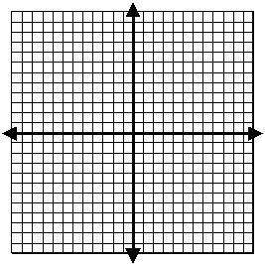

2. y < 3x
y ≥ x - 4

