Good news! Your parents just said they would upgrade your cell phone and prepay $25 each month for the plan of your choice. To make the best decision, you've found the two plans below. Compare the cell phone plans and choose the one that's right for you.
 | Voice Minutes | Text Messages
Plan A | $.05 / minute | $.15 / message
Plan B | $.10/ minute | $.05/ message

1. If you choose to only send text messages, which plan will allow you to send the most? How many will you be able to send?

2. If you choose to only talk on the phone, which plan will allow you to talk the longest? How long will you be able to talk?

3. If you talk for a total of two hours in a month, how many texts will you be able to send under Plan A? Plan B?

4. Write an equation for each plan to represent the number of text messages (x) and the number of voice minutes (y) you will be able to use with the $25.

5. Graph the two equations on the same coordinate grid.
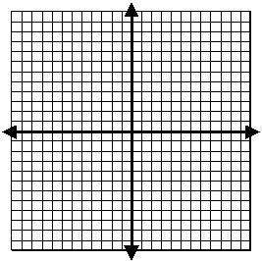

6. Where do the graphs of the equations intersect? What does this point represent?

7. Which plan would you choose? Why? Use mathematical reasoning in explaining your choice.

