**Given the indicated parts of triangle ABC with γ = 90°, find the exact values of the remaining parts.**

1. α = 30°, b = 20 2. β = 45°, c = 30 3. a = 5, b = 5 4. b = 5 $\sqrt{3, }$ c = 10 $\sqrt{3}$

**Given the indicated parts of triangle ABC with γ = 90°, approximate the remaining parts.**

5. α = 37°, b = 24 6. β = 71°51', b = 240.0

7. a = 25, b = 45 8. c = 5.8, b = 2.1

**Given the indicated parts of triangle ABC with γ = 90 $°$, express the third part in terms of the first two.**

9. α, c; b 10. β, b; a 11. α, a; c 12. a, c; b

13. A person flying a kite holds the string 4 feet above ground level. The string of the kite is taut and makes an angle of 60° with the horizontal. Approximate the height of the kite above level ground if 500 feet of string is payed out.

14. A pilot, flying at an altitude of 5000 feet, wishes to approach the numbers on a runway at an angle of 10°. Approximate, to the nearest 100 feet, the distance from the airplane to the numbers at the beginning of the descent.

15. A guy wire is attached to the top of a radio antenna and to a point on horizontal ground that is 40.0 meters from the base of the antenna. if the wire makes an angle of 58°20' with the ground, approximate the length of the wire.

16. A rocket is fired at sea level and climbs at a constant angle of 75° through a distance of 10,000 feet. Approximate its altitude to the nearest foot.

17. An airplane takes off at a 10° angle and travels at the rate of 250 ft/sec. Approximately how long does it take the airplane to reach an altitude of 15,000 feet?

18. A rectangular box has dimensions 8" x 6" x 4". Approximate, to the nearest tenth of a degree, the angle θ formed by a diagonal of the base and the diagonal of the box.

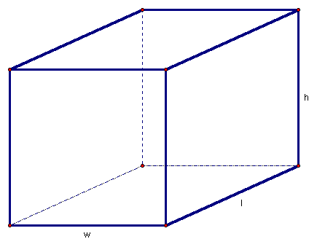



θ

4

6

8