Find the period and sketch the graph of the equation. Show the asymptotes.
1. y = 4 tan x 2. y = 1/4 tan x
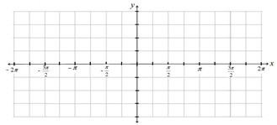

3. y = 3 cot x 4. y = 1/3 cot x

5. y = 2 csc x 6. y = 3 sec x
7. y = tan (x - π/4) 8. y = tan 2x
9. y = tan $\frac{1}{4}x$ 10. y = 2 tan (2x + π/2)

11. y = -1/4 tan ($\frac{1}{2}x+ \frac{π}{3})$ 12. y = cot (x - π/2)

13. y = cot 2x 14. y = cot $\frac{1}{3}x$

15. y = 2 cot (2x + π/2) 16. y = $-\frac{1}{2}$cot $(\frac{1}{2}x+ \frac{π}{4})$
17. y = sec (x - π/2) 18. y = sec 2x

19. y = sec $\frac{1}{3}x$ 20. y = 2 sec (2x - π/2)

Sketch both (a) and (b) on the same graph.
21. (a) y = |sin x| (b) y = |sin x| + 2 22. (a) y = |cos x| (b) y = |cos x| - 3

23. (a) y = tan 0.5x (b) y = tan [0.5(x + π/2)]

